**M4 (Mass Mail Merge Macro)** (PDF or other file attachments)

This mass mail merge tool was developed for the Remediation process for Compliance. A few rules for use:

* It will ONLY (currently) work from a user’s desktop and it has to have the code modified to include said user’s id
* The macro code is commented to include what to leave alone and what can be modified or has to be modified.
* These instructions were originally written for the Remediation process but can be used for any send or BCC address and any user.
* The PDF files must be in ONE folder, may be copies if they are in the project folder on the user’s desktop.

Go into the folder named **Remediations for E-Mail Merge (or designated project folder)** on your desktop. Find the ***M4 Mail Merge <username>.xlsm*** file. This file is hard coded to look in this folder for the files you are about to merge and CANNOT be moved (until this whole process is done) as it will break it.

Each team member must have a *custom M4 Mass Mail Merge Macro* workbook. These are specific to each team member and are hard coded in the macro for each person. The macro must specifically be a folder labeled ***Remediation Notice Mail Merge (can be named something else but must be changed in the macro to reflect the folder name and is case sensitive)*** on your desktop.

For each file you will need the following 3 pieces of information:

1. Eaddress – the email address of the *Program Administrator (or other addressee such as a provider’s main email, only one email address per line is allowed, if more than one needs to be used duplicate the line with the secondary email address)*
2. Subject - <Key> <Site Name> <Parent Agency> (can be anything desired)
3. Attachment – the file name <key>_Remediation (will come from the list of files)

To easily fill in the file path for a long list of files to be sent (Attachment Field):

1. Go to **Remediations for E-Mail Merge (or your project’s designated folder)** on your desktop where you will find a long list of files you want to send.
2. Select all the files using **CTRL-A** (Select All) then hold **Shift *and* Right** click. The pop up menu will have an option to **Copy as Path**

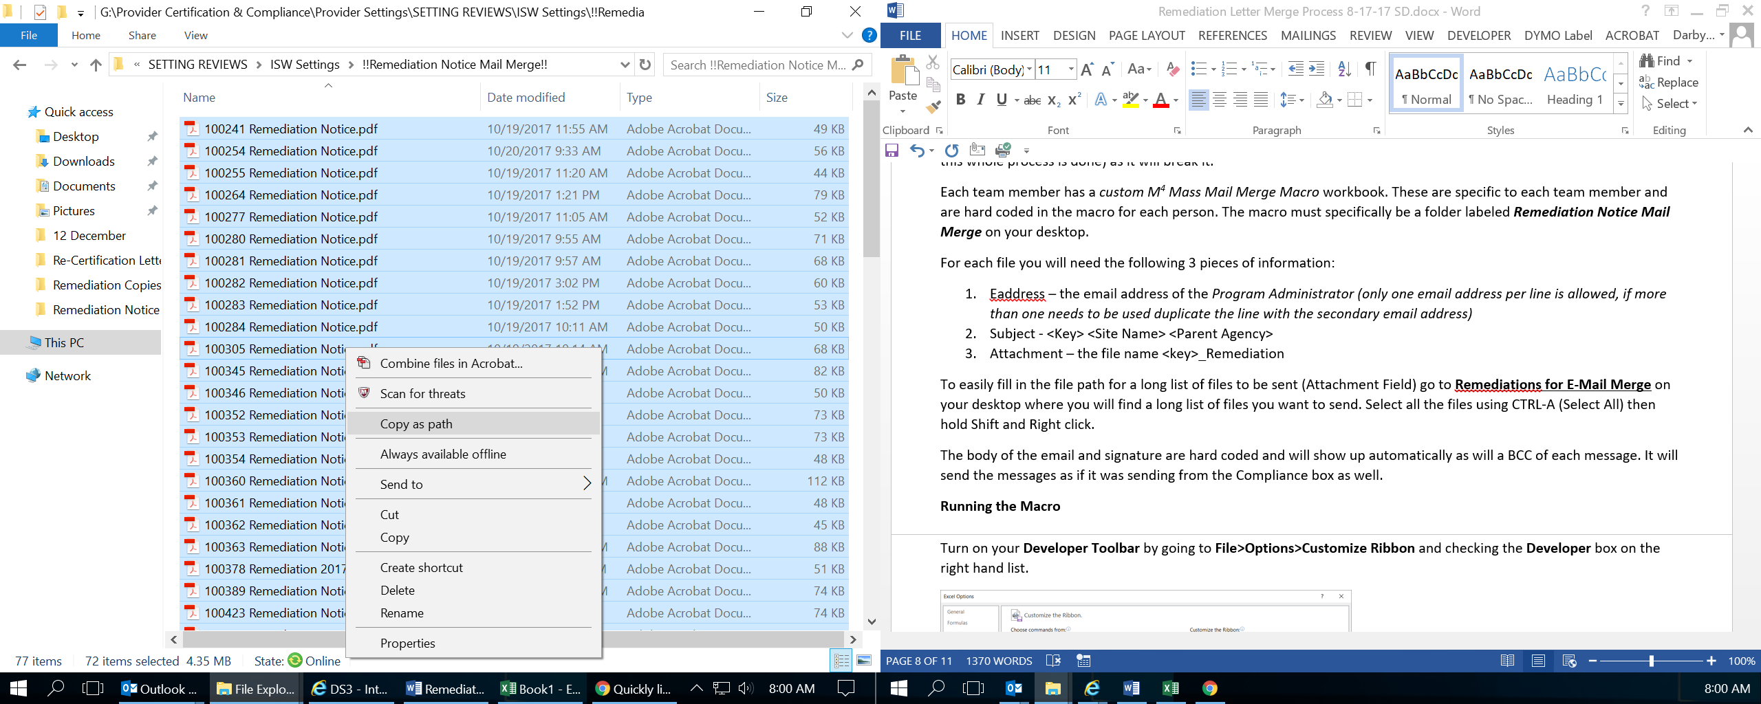

1. Go into the M4 workbook and **Paste** (CTRL-V) the results under attachment.

You only need the file name for this column because the file path is hard coded into the macro, so to quickly eliminate the unnecessary data you will highlight the file path up until the file name.

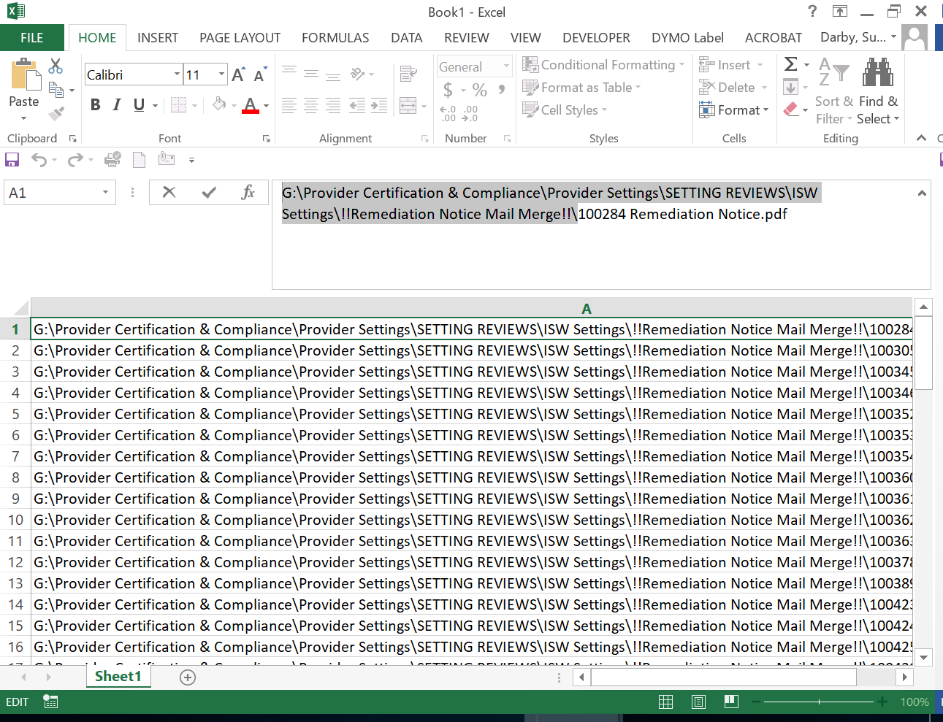

1. Use **CTRL-C** (Copy) to copy the data
2. On the *Home Tab* go to **Find & Select>Replace**

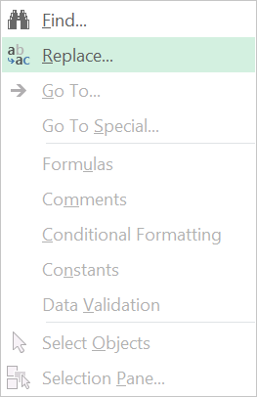

1. **Paste** the file path in the **Find what:** field

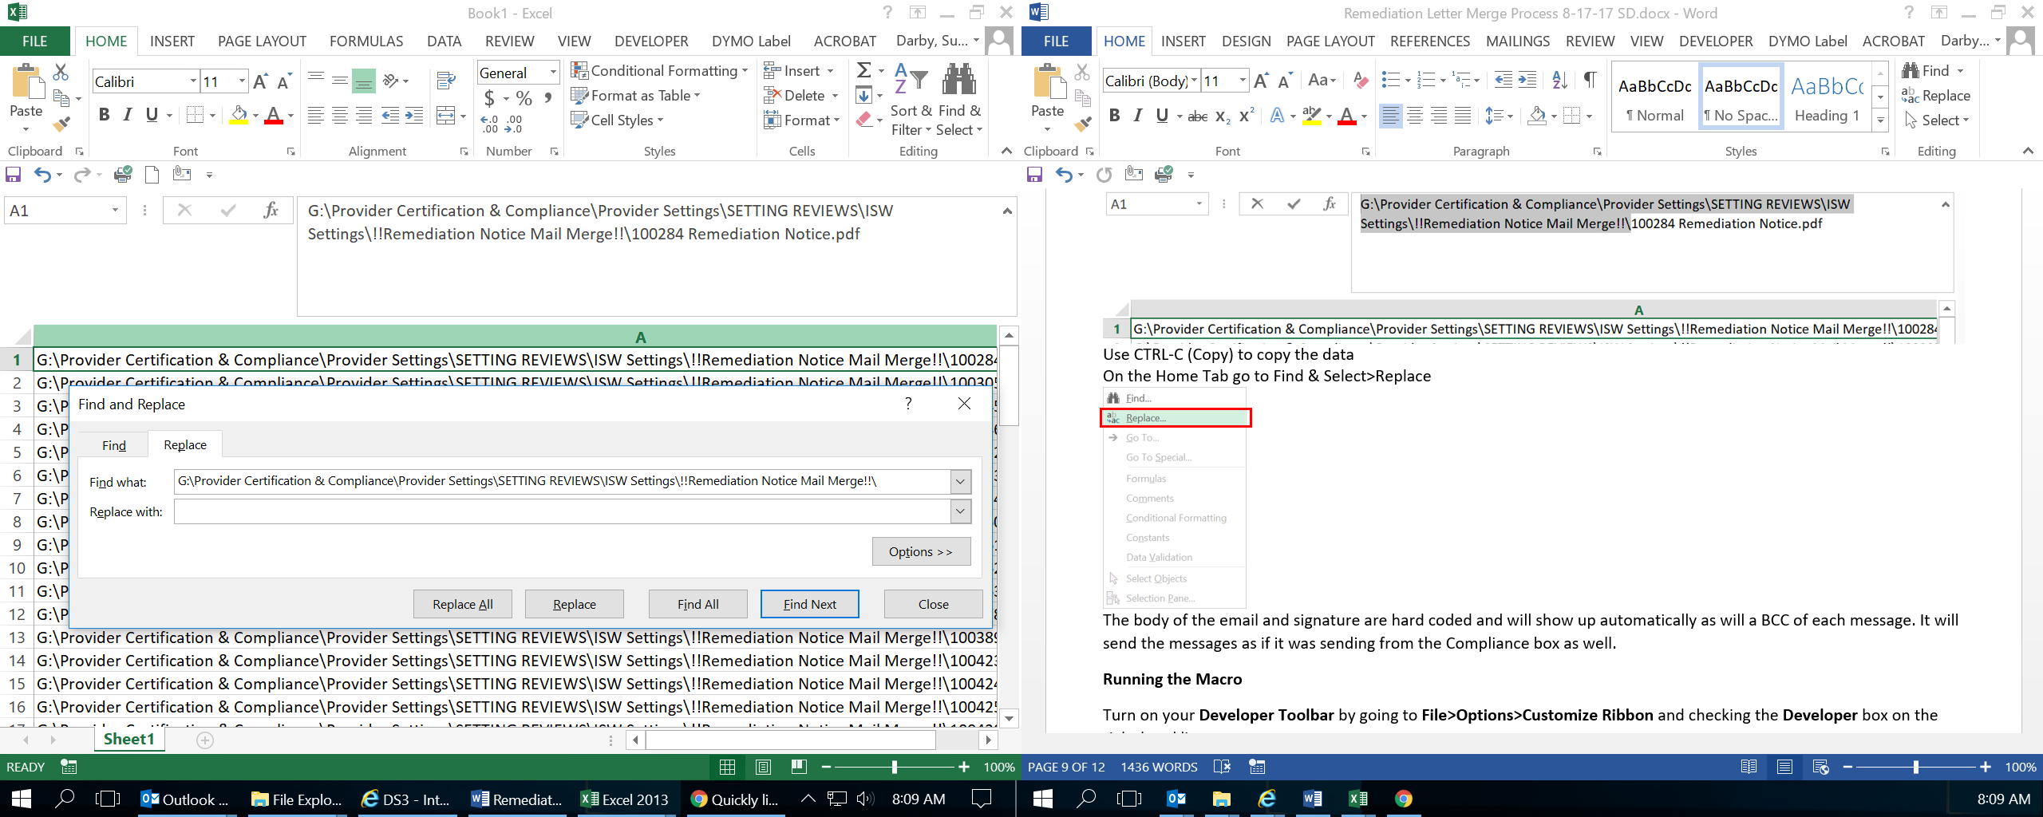

1. Leave the **Replace** with box empty and click **Replace All**.

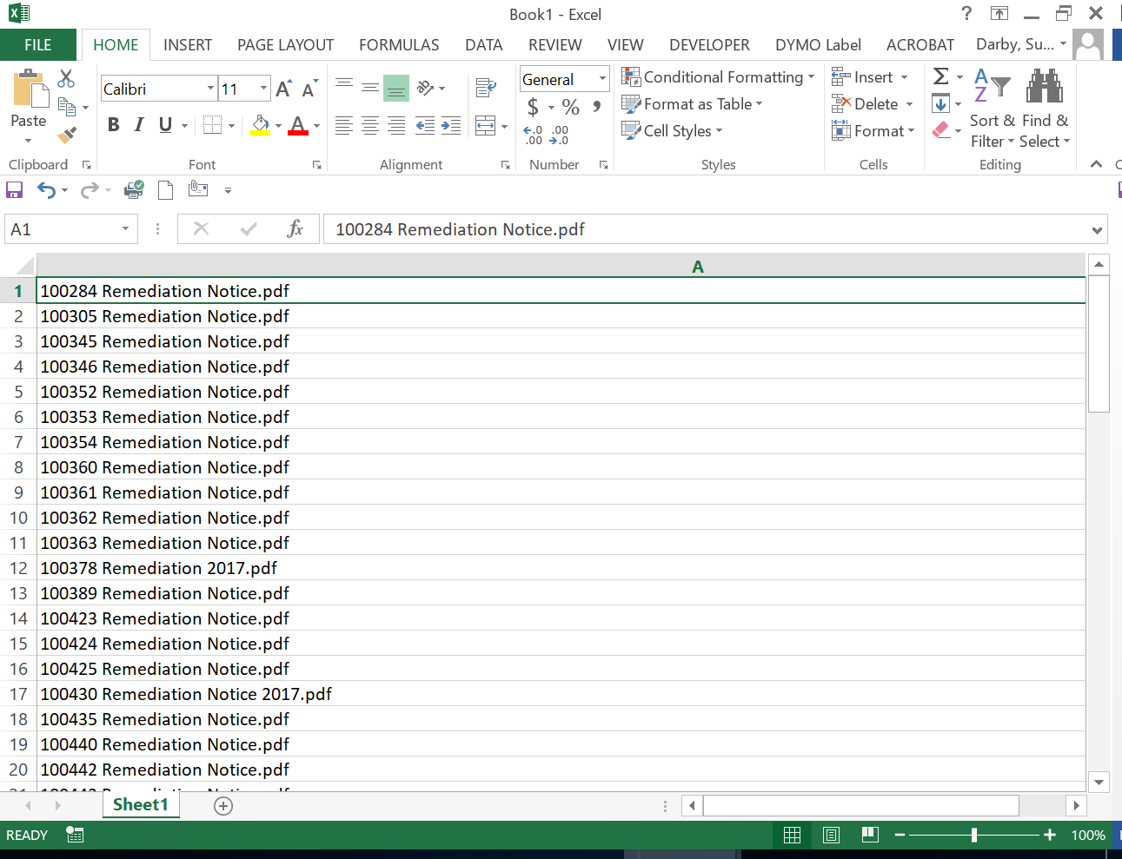

1. You are left with just the file names.
2. Check that your **subj** and **attachment** names are the ***same*** and belong to the email address under **eaddress!**

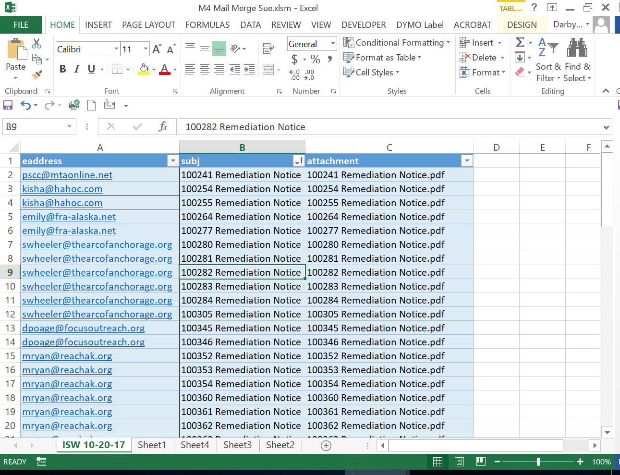

The body of the email and signature are *hard coded* and will show up *automatically* as will a BCC of each message. It will send the messages as if it was sending from the Compliance box as well.

**Running the Macro**

1. Turn on your **Developer Toolbar** by going to **File>Options>Customize Ribbon** and checking the **Developer** box on the right hand list. (only have to do this once)

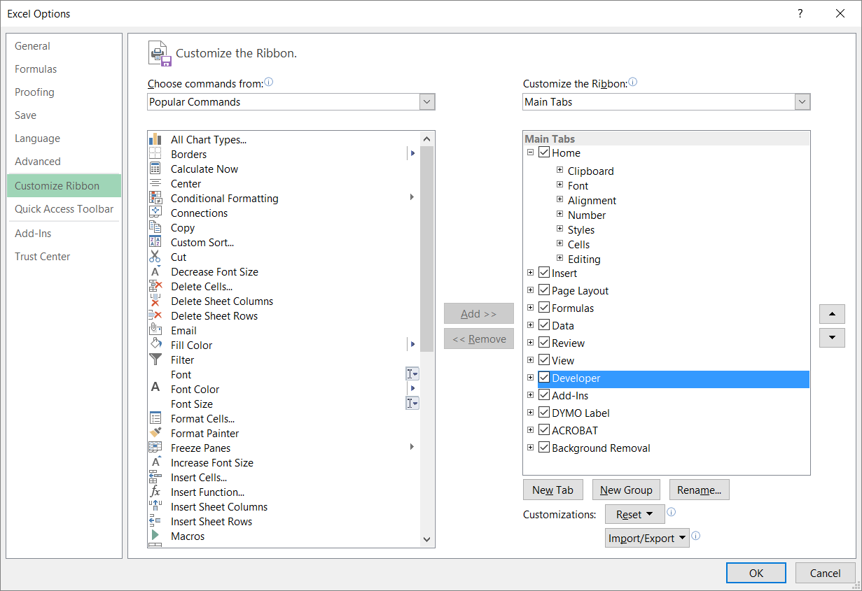

1. Go to the **Developer** toolbar (now found next to View)
2. Click **Macros**

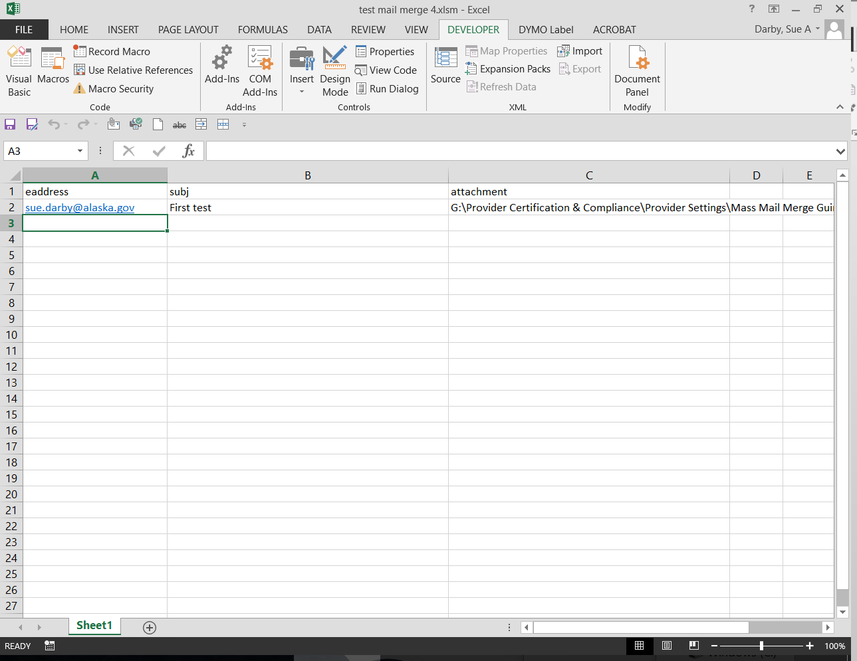

1. The **Macro** dialog will pop up, click **Run**

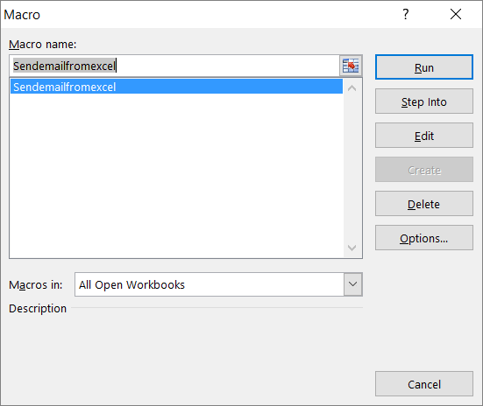

1. The process will run automatically with an **OK** button for each letter going out (no I have no idea how to fix this at this time)
2. Once the batch is sent move the files to an appropriate folder for that service i.e. ISW, Adult Day etc.
3. MOVE the list to a “*Service m-d-y*” named sheet and leave **Sheet 1** *blank* for the next batch. (another hard coded piece to this tool)

**Modifying the Macro**

Go to the **Developer Tab>View Code**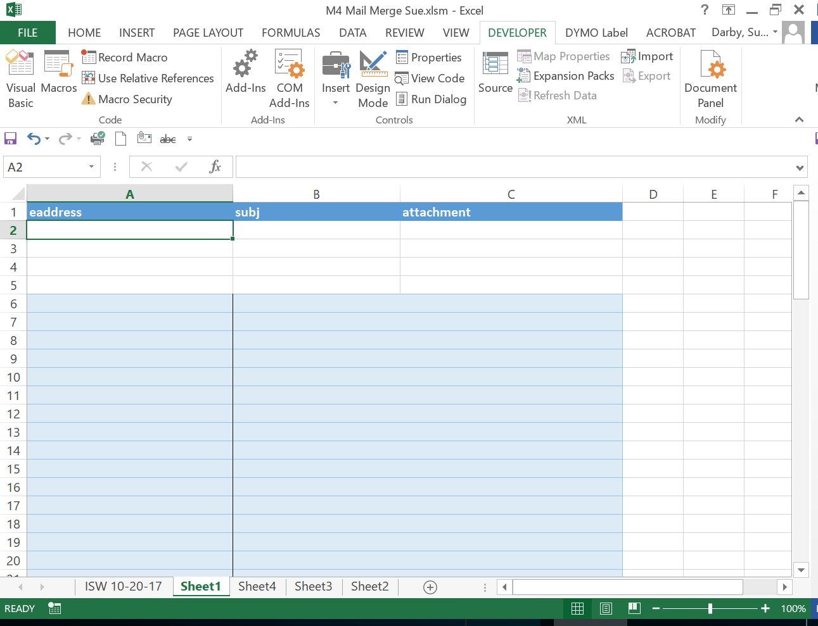

The macro VB.net code will pop up in a new window. The code is commented with instructions and information on the tool including how to activate the *Outlook Object Library* within *Excel* so that the macro will function correctly.

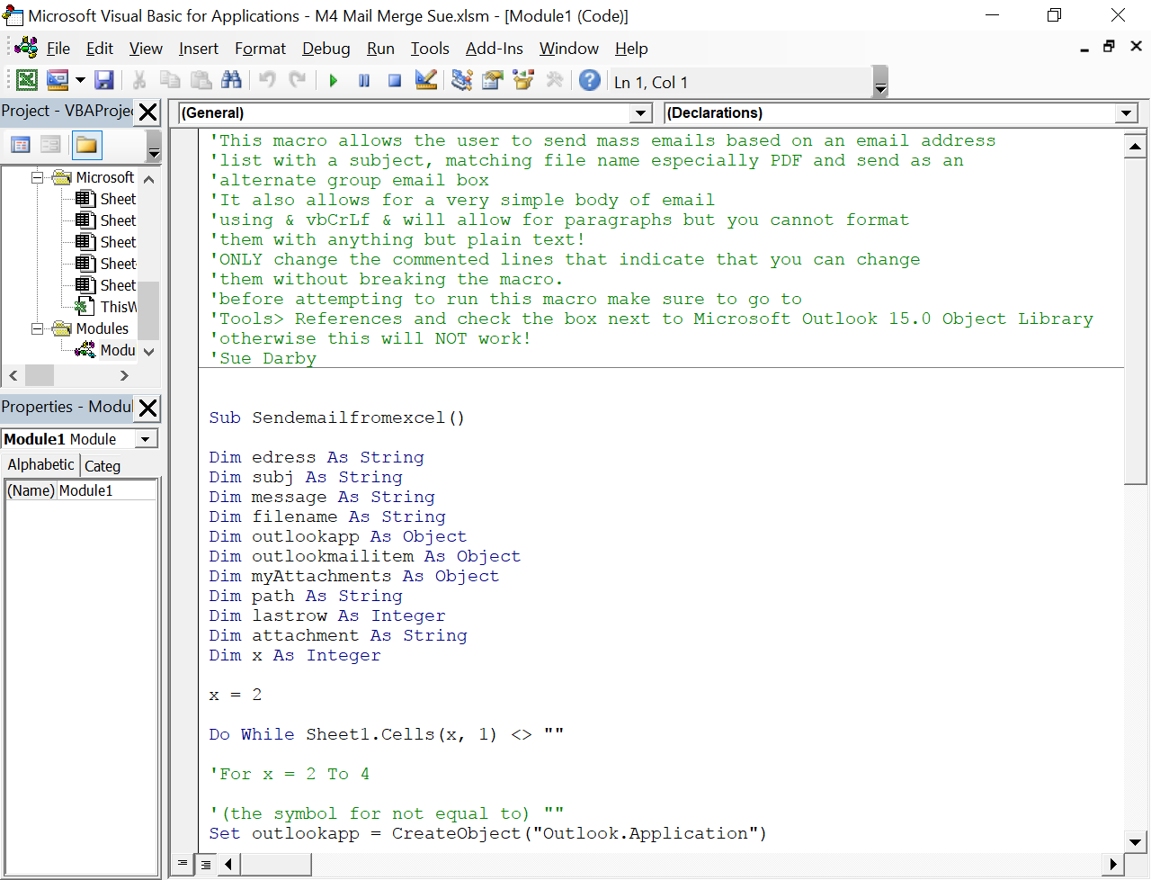

Below is the line that must be coded to a specific folder on your desktop for the macro to live and function correctly. The two pieces that need to be changed are:

1. The user name (from sadarby to your PC login)
2. The name of the folder (from Remediation Notice to whatever your project is called where the M4 Mail Merge macro file lives.)

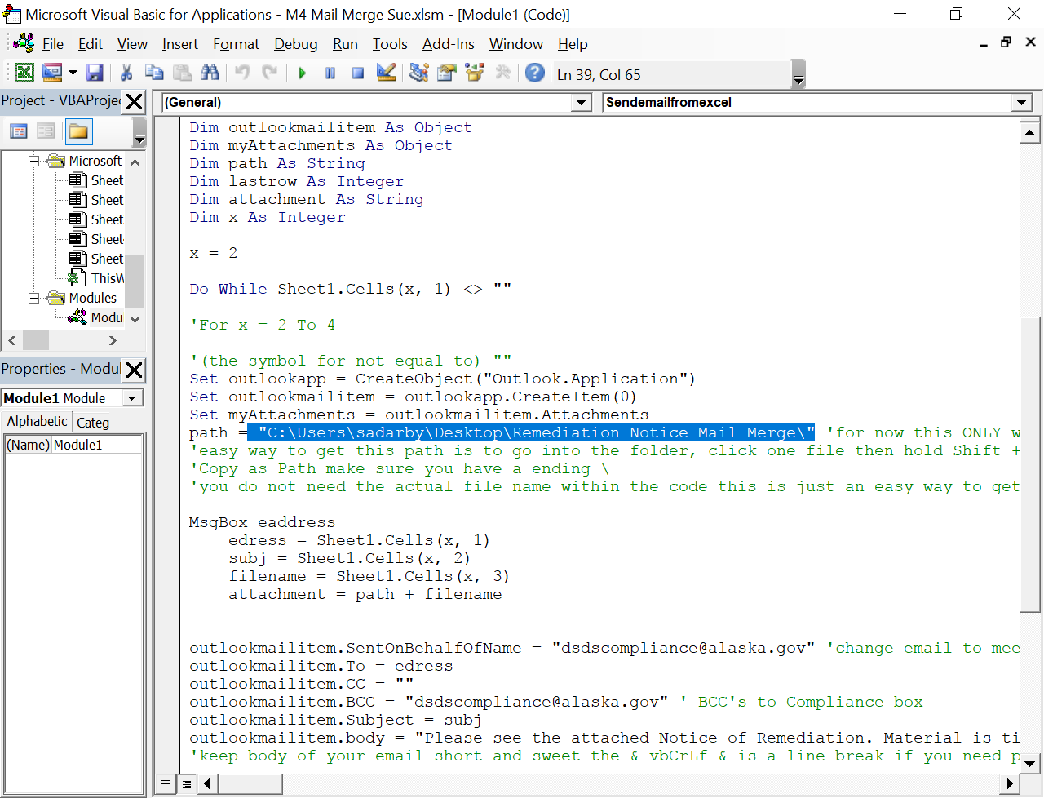

Further down you can change the SentOnBehalfOfName email address to any shared or individual email box desired

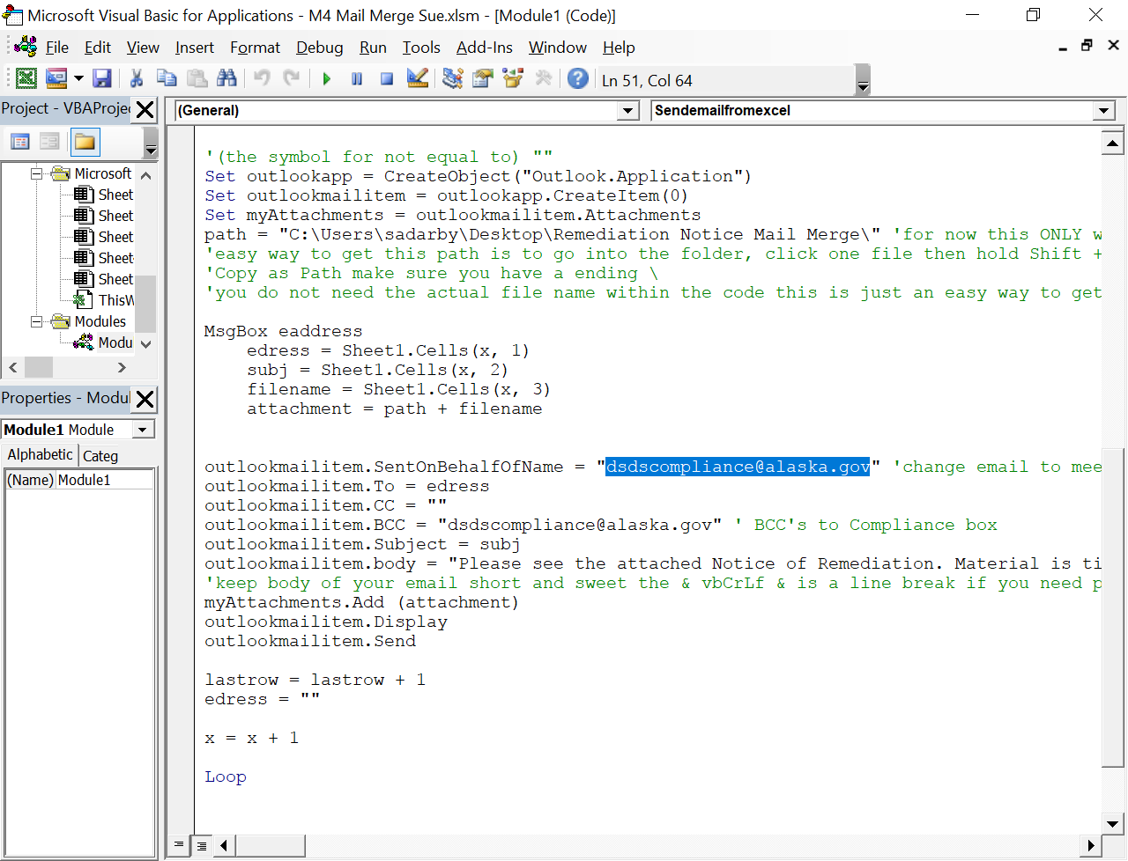

You can also add a BCC or CC email address

Email addresses need to be surrounded by double quotes “

